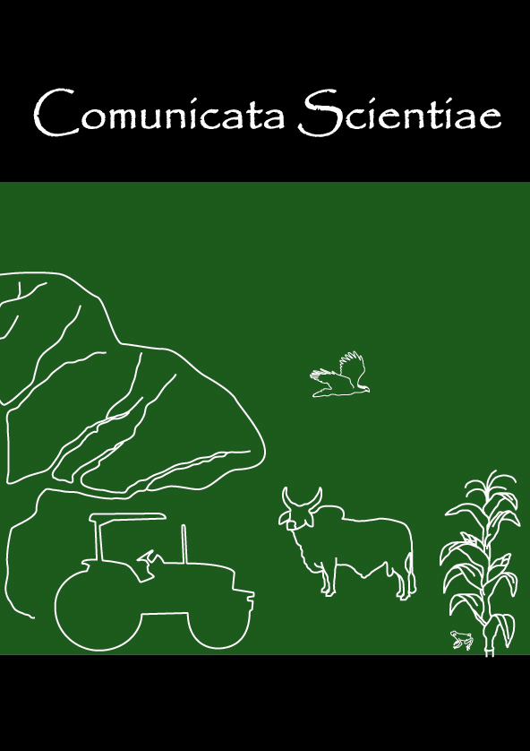

To: Dr. Ítalo H. L. Cavalcante
Editor-in-Chief of Comunicata Scientiae

http://www.ufpi.br/comunicata

Covering Letter

We are sending attached an article with title Aged garlic extract enhances Paraoxonase 1 activity and suppress oxidative stress in CCl4-intoxicated rats for submission in Comunicata Scientiae. The authors are Khaled G. Abdel-Wahhab, Yasser A. Khadrawy, Fathia A. Mannaa. We assure that this article has not been sent to another journal.

Section of Publication:

Plant Production and Crop Protection
Soil and Water
Animal Production and Health
Environmental Sciences
Genetics and Genetic Improvement
Food Technology
Rural Engineering
Forestry Science

Yours faithfully,

Dr. Fathia Mannaa
Medical Physiology Department,
National Research Centre, Dokki,
Cairo, 12311, Egypt

- Author for Correspondence -

