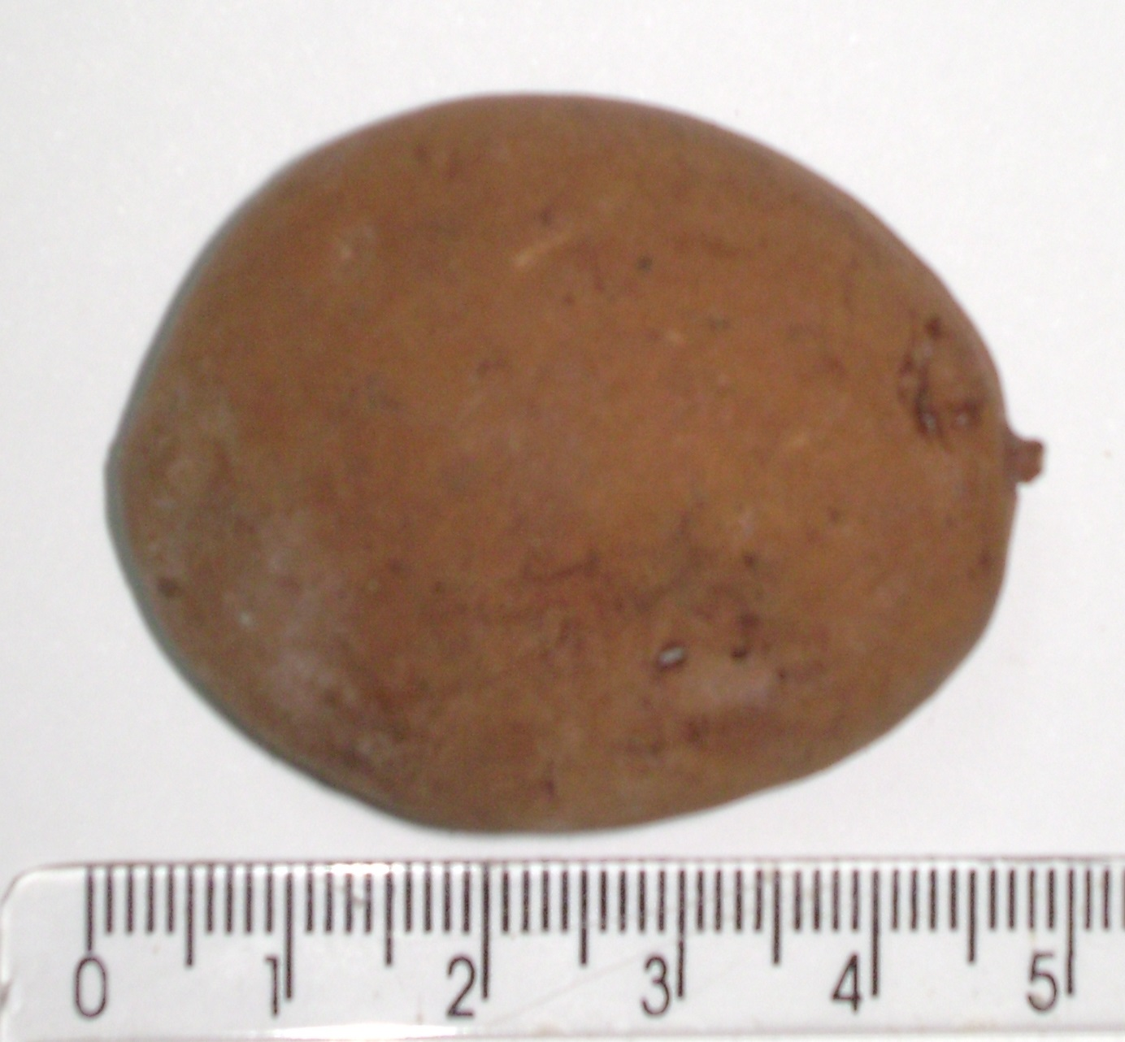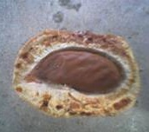
B
A
C
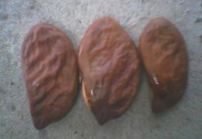

Figure 3. Fruit external part (A), fruit longitudinal face (B) and almonds (C) of Gurguéia nut.

