Figures
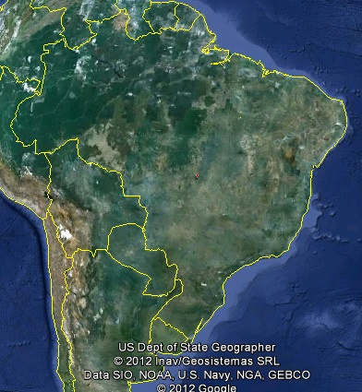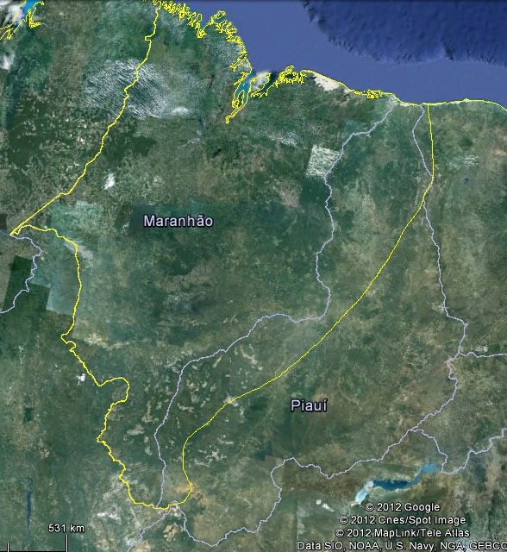
Brazilian Mid-North region
Figure 1. Brazilian Mid-North region where Gurguéia nut plants are natively found.

